I will put in my box
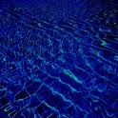
A taste of the clearest
Bluest water any one ever found,

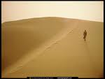
A gear of the white
Wonderful Arabian sands,

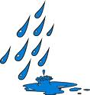
A rain drop from the coldest
Place ever recorded,
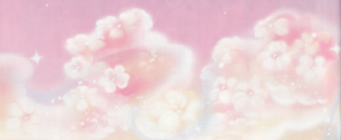
I will jump in my box on the pink fluffy
Clouds,

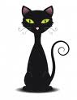
With black cats embodied
On the top keeping watch for
Any UN wanted visitors,

I will take the last look from
A great gran, whose smile will,
Last forever,

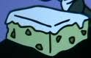
The bottom covered in an old
Moldy cheese from the cafeteria
In M.I.S

I happened to see the man who made the this marvelous box man who made it with only the finest wood in 1982

I saw the bluest water ever found a glare of the white Arabian sands a fresh summer’s morning a rain drop from the coldest place the black cat’s embodied on the top of three box a last smile from a great gran and the moldy old cheese on the floor of M.I.S cafeteria.

